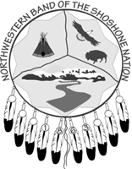
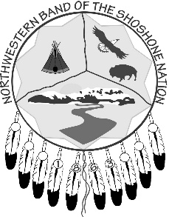
NORTHWESTERN BAND
of the SHOSHONE NATION
2575 Commerce Way – Ogden, UT – 84401
Phone (435) 734-2286 – Fax (435) 734-0424
Enrollment
APPLICATION for ENROLLMENT
Full Legal Name: _______________________________________________________________
Sex: ________________________ Date of Birth: ____________________________________
Current Address (include City, County, State, & Zip Code): _____________________________
______________________________________________________________________________
______________________________________________________________________________
Phone Number: ____________________________ SSN: _______________________________
Place of Birth (include City, County, State, & Zip Code): _______________________________
______________________________________________________________________________
Father’s Name: _________________________________________________________________
Father’s Enrollment #: ___________ Date of Birth: ____________________________________
Mother’s Name: ________________________________________________________________
Mother’s Enrollment #: __________ Date of Birth: ____________________________________
Name of Ancestor on Base Roll & Enrollment #: ______________________________________
______________________________________________________________________________
Previously Enrolled Tribe? Y / N If Yes, identify: _________________________________
Date of Relinquishment: _________________________________________________________
(Must include Relinquishment Letter from Previously Enrolled Tribe)
Name of Person Making Request: __________________________________________________
(If not self, person making request must be legal parent or guardian of individual)
Signature: ______________________________________ Date: _________________________
For Enrollment Committee Use
Please Circle: Approved / Denied Date: ___________
Initial of Committee Members: __________ __________ __________

